Week 3
Bank database
1. creating tables(branch, bankaccount, bankcustomer, depositor, loan, loancustomer)
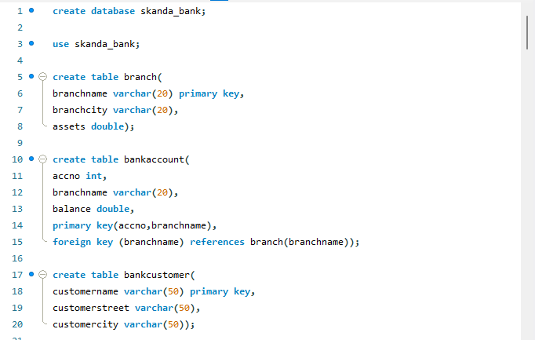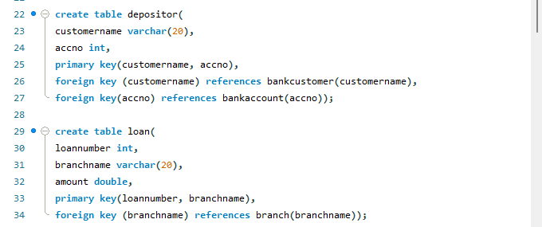

2. Inserting five tuples into tables.
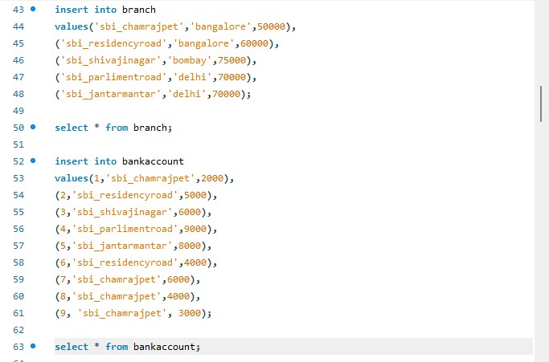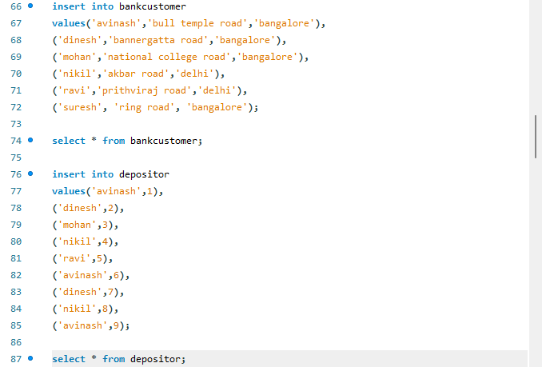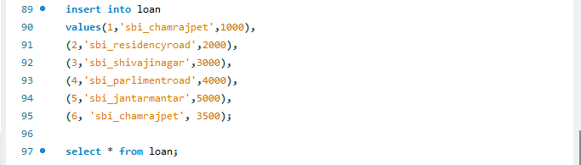
3. display the branch name and assets from all branches in lakhs of rupees and rename the assets column to ‘assets in lakhs.
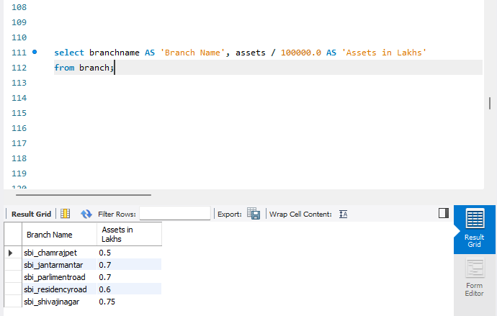
4. Find all the customers who have at least two accounts at the same branch (ex. Sbi_residencyroad).
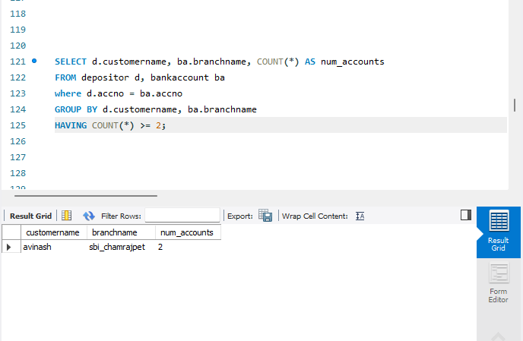

5. create a view which gives each branch the sum of the amount of all the loans at the branch.
